Cost Management: estimate, budget and review
  - Portal-first beginner hands-on lab
LBS | Attendee edition v2 | 26 October 2026

Before you start
Environment: use the instructor-approved sandbox, group, region, tiers and spending limit. Create only your own disposable resources. The walkthrough uses fictional data. No cloud resource is created by reading this document.
Materials: copy Labs\AppServiceSqlSample locally when the lab needs the .NET sample. Complete its setup from 02_Windows_And_Local_SQL_Setup.docx. Do not repeat resource creation if you already completed the same lab in the main guide.
Admin assistance: Contributor does not automatically grant IAM role assignment, SQL SELECT, Blob data access or Service Bus data access. Have the authorised administrator perform only the privileged step. Never bypass policy.
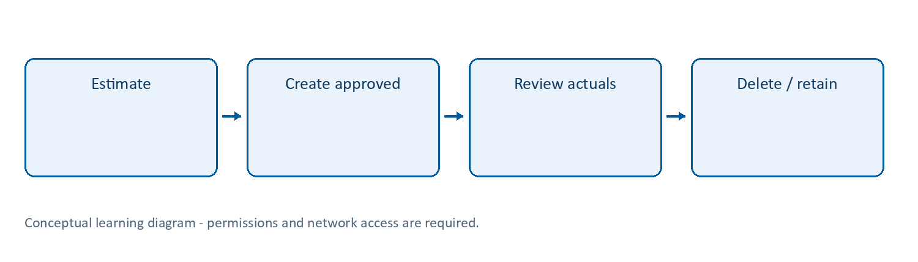
Learning flow

Cost Management | Know what the design costs
What: Azure tools for viewing/allocating costs, budgets, alerts and optimisation. The Pricing Calculator estimates a design; Cost Analysis reports available billing data.
Why/when: cloud makes resource creation easy; forgetting idle compute, log ingestion, retention, messages and storage can create unexpected bills.
How: estimate before creating, tag resources, inspect actuals at an authorised scope, configure budgets and notifications, review and delete disposable resources. Follow Lab 5.
Example: choose an approved small lab plan, estimate SQL/monitoring costs and remove the namespace/plan after the course.
Tips and traps: budget alerts are not a hard spending cap. Cost visibility can lag. A stopped app’s plan can still bill. Consumption pricing does not mean zero minimum/related costs across every service. Tags are not always inherited. Optimisation must preserve security, required availability and useful diagnostic data.
Reference: https://learn.microsoft.com/azure/cost-management-billing/costs/overview-cost-management

Lab 5 | Cost Management and budget (core)
Time: 60-90 minutes. Needs: actual Azure resource choices and approved cost visibility. Cost: the budget itself does not stop resources or impose a hard spending cap.
- Open https://azure.microsoft.com/pricing/calculator/. Add your chosen App Service tier, Azure SQL compute/storage, Application Insights/Log Analytics ingestion and retention, Functions plan, Service Bus tier, Blob Storage and Key Vault operations as applicable.
- Select the intended region and currency. Enter realistic usage assumptions, including idle paid plans. Record an estimated monthly amount and the assumptions; do not treat it as a quote.
- In the portal open Cost Management + Billing > Cost Management > Cost analysis at an authorised scope.
- Filter to your lab group and the current date range. Group by Service name or Resource. New charges can take time to appear. Zero visible cost does not prove the service is free.
- Under Budgets > Add, select the authorised scope, monthly period and instructor-approved amount/currency. Add actual-cost alerts at 50%, 80% and 100% if supported, plus forecast alerts if available. Use an approved recipient; do not subscribe unrelated users.
- If resource-group budget creation is unavailable, ask the instructor to create it or review a prepared example. Billing roles do not automatically allow budget administration at every scope.
- Tag resources consistently. Group-level tags are not automatically inherited by all resources. Inspect individual tags.
- Identify three safe improvements: delete idle lab plans, use an approved smaller SQL tier, avoid unnecessary log verbosity, adjust retention under policy, and delete unused messaging/storage resources. Record performance/reliability trade-offs.
- Explain why Stop web app does not stop App Service plan billing; stored SQL data, a Service Bus namespace, log retention and storage can continue to incur charges.
Cost record | Your result
Region / currency / date
App Service tier and monthly assumption
SQL compute/storage assumption
Monitoring ingestion/retention assumption
Messaging, Functions and Storage assumption
Total estimate and approved budget
Three improvements and risks
Checkpoint: saved estimate, visible cost filters and budget/alert evidence (or documented permission fallback). Never rely on a budget to shut down a runaway workload.

Lab 18 | Independent cost review and billing traps
What/why: identify the resources that remain billable when application traffic stops.
Needs: Lab 5, an approved cost scope and your resource inventory. Billing data can be delayed.
- Open Cost Management > Cost analysis, verify the scope, select current month and filter your group.
- Select a daily view and group by Resource or Service name. Record the date, currency, visible period and whether data is preliminary/delayed.
- Change one filter and explain how it changes the question. Avoid comparing a filtered group view with an unfiltered subscription total as if they match.
- Save the view where permitted, using an approved personal/shared visibility option. Never share a whole organisation’s cost export with attendees.
- Open your existing budget, verify amount/period/recipients and inspect actual versus forecast threshold configuration.
- With permission, use the relevant action group’s test function for notification testing if the budget is connected to one. Budget threshold emails are not universally manually triggerable; do not generate spend to force a notification.
- Inventory every App Service plan, SQL database/server, storage account, Service Bus namespace, Function plan and workspace in your group. Record the major cost driver for each.
- Compare a stopped web app with its plan: explain why stopping the app is not a general plan-billing shutdown. Do not stop shared resources to experiment.
- Update the calculator from actual chosen tiers, then choose a deletion deadline and owner. Check costs again after the expected billing delay following cleanup.
Expected: an explainable cost view, budget/notification evidence with its limitations, and a resource-by-resource deletion plan.
Tips: notifications are not cost caps; reserved/committed pricing is not a beginner lab purchase; diagnostic exports, alerts and retention have costs of their own.
Cleanup: remove obsolete practice alert rules/action groups only if you own them; do not delete an organisational budget.

Completion record and cleanup
Record | Your observation
Subscription/group/region and actual resource names
Expected result and actual result
Log/table/metric, time range and evidence
Identity, role/scope and network restrictions
Idle/usage/logging cost driver
Cleanup or retention owner/deadline
Only mark a lab passed after its functional checkpoint. A deployment success or empty error table alone is not proof. Mark blocked permissions honestly.
Clean up only your own disposable objects; removing a diagnostic setting does not erase retained logs, and stopping an app does not stop every cost. Follow Lab 13 in the main guide. Keep secrets/customer information out of evidence.
Verification scope: these instructions and Word file structure were reviewed. Automated Word pagination could not be completed; preview before printing. Azure execution, prices, policy, permissions, plan/runtime availability and portal labels require instructor rehearsal in the actual training subscription.

